READER ID 240-03

LECTURER: Sherrill Halbe Ph.D., ASID, CID, IDEC

PLEASE NOTE THAT THESE ASSIGNMENTS ARE THE ONLY ASSIGNMENTS THAT WILL BE WRITTEN OUT FOR YOU. OTHER ASSIGNMENTS WILL BE EXPLAINED IN CLASS.

NATURE PAPER: One characteristic of design is that it is a plan for order. Another characteristic is that design is related to the basic natural laws of growth and order. Design is all around us. Take time out to quietly observe COLOR and DESIGN ELEMENTS AND PRINCIPLES in nature as you walk, sit in nature, or gaze out of a window. Take a photo of something from nature that appeals to you such as a pinecone, tree, etc. and make a color copy of it. Type a one-page paper about what you experience and be prepared to share the experience with the class. You will be using your experience to create a nature design.

Write about your color and design observations and responses. Take note of all design ELEMENTS and how they are ordered, i. e., DESIGN PRINCIPLES. Take note of COLOR; SHAPES in SPACE; LINEAR features, TEXTURES and PATTERNS, SPACE that makes up shapes, and LIGHTING effects. Are the elements BALANCED? Is there EYE MOVEMENT with REPETITION of elements or linear movement? Are the elements HARMONIOUS, dull, exciting, too little, or too much? Is there EMPHASIS? Is there CONTRAST? Take note of your response to how the color and design elements make you feel. What emotions do you feel? Does the space have AESTHETIC qualities?

NATURE DESIGN: You will be creating a design inspired by nature. Measure one-inch borders on drawing paper. Take a picture of something from nature such as a pinecone and make a color copy of it. Sketch a portion of an object from nature such as a pinecone and enlarge the image to create a design on the drawing paper. You will paint the image with two pure colors from the color wheel and two neutrals. This is how to select two hues and two neutrals: Select 2 hues of your choice from the color wheel. These 2 colors will be painted on your image in their pure form. To mix each neutral find each pure color’s complement on the color wheel. Mix the chosen color, the complement, black and white in any proportion. Now do the same thing with the other chosen color and mix it, the complement, black, and white. Now you have 2 neutrals to paint on the image. You will only use these 4 colors on your finished design. I will look for only 4 colors when I grade your work. You will be graded according to the Self-Evaluation/Critique Form. Staple the color photo copy of the nature object to the Critique form and attach it to your design as instructed.

Reminder: paint the entire surface with the colors; cut frayed edges; write your name, section, and assignment name, i. e., NATURE DESIGN, on the back.

PACKAGE DESIGN-EGG DROP
Design a 6 x 6 x 6 inch constructed package housing one raw chicken egg, which needs to survive an approximate 2-story drop off the Student Union. A prototype or sketch will be required prior to the final drop.

Criteria:

Do not use commercial packaging material.

No cube or square shape or form. It needs to be another shape or form that would be about 6 x 6 x 6 inches. No strings attached or parachutes as strings will be cut off.

Must be made of paper or poster board. NO FOAM CORE.

The exterior and interior will be painted with a line design and your choice of a color scheme. Don’t worry about this until I discuss the procedure. Colors may be neutralized and use of black marker OK.

No commercial packing material such as bubble wrap, shredded paper, popcorn, and
no food stuff or water.

The design should be aesthetic, functional, saleable, individual, and attractive to the customer, inside and outside. It should be able to sit on a shelf for sale.

The design should open easily.

Sealing is okay if aesthetic.

House your egg in a plastic bag in case it breaks.

INSTRUCTOR: Sherrill Halbe, Ph.D., ASID, CID, IDEC

CRITIQUE FORM

PERIODICALLY SELF-EVALUATIONS WILL BE USED WITH THE USE OF THIS CRITIQUE FORM TO EVALUATE ASSIGNMENTS AND WILL BE AVERAGED INTO THE GRADE. THIS FORM WILL SHARPEN YOUR JUDGEMENT AND AWARENESS OF DESIGN.

SAVE, MAKE COPIES, AND USE THIS FORMAT WITH EACH PROJECT UNLESS INDICATED. For each project, fill out the following and send me an image of this form with an image of the project via email. Label the email with ID240-03_assignment name and #_ last name, first initial e.g. 240-03_naturedesign#3_halbes

I Describe technique in detail. (USE BACK OF PAPER TO CONTINUE)

II Describe expression in detail. (USE BACK OF PAPER TO CONTINUE)

III Eight (8) point format as below. Give yourself a point (s) if the item is not applicable.
POINTS

1 POINT CLASSROOM PARTICIPATION

1 POINT CRITIQUE FORM

2 POINTS PROJECT MEETS ASSIGNMENT CRITERIA

1 POINT PROJECT MEETS PRESENTATION CRITERIA

2 POINT PROJECT CONSIDERS/DEMONSTRATES ALL DESIGN PRINCIPLES
CIRCLE DESIGN PRINCIPLES: Unity-harmony, eye-movement, balance, rhythm, variety, contrast, proportion, and emphasis. Circle if you want the points.

1 POINT PROJECT CONSIDERS/DEMONSTRATE ALL DESIGN CHARACTERISTICS.
CIRCLE DESIGN CHARACTERISTICS: Design is an expression of its material; fulfills
its purpose or function; has individuality; is a plan for order; and that it is related to the basic natural laws of growth and order (Bevlin 1970).

TOTAL POINTS HERE

INSTRUCTOR: Sherrill Halbe, Ph.D., ASID, CID, IDEC

REFERENCES AND PARTIAL READING LIST

Alexander, C., Ishikana, S., Silverstein, M., Jacobsen, M., Fiksdahl-King,I., & Angel, S. (l977). A pattern language. New York: Oxford University Press.

Atterberry, G. & Block, J (2000). Design Essentials: A Handbook, (2nd ed.). Upper Saddle River, NJ: Prentice Hall.

Ballast, D. K. (1992). Interior design reference manual. Belmont, California: Professional Publication.

Benyus, J. M. (1997). Innovation inspired by nature. New York: Perennial, An Imprint of Harper Collins Publishers Inc.

Bevlin, M. E. (1970). Design through discovery, New York: Holt, Rinehart and Winston, Inc.

Ching, F. D. K. (1987). Interior design illustrated. New York: Van Nostrand Reinhold Company.

Cresti, C. (1969). Twentieth-century masters: Le Corbusier. New York: Hamlyn.

Edwards, B. (1989). Drawing on the right side of the brain. Los Angeles: Jeremy P. Tarcher, Inc.

Fehrman, K. R. & Fehrman, C. (2004). Color the secret influence. Upper Saddle River, New Jersey: Prentice Hall.

Finkelstein, P. (1997). The art of faux. New York: Watson-Guptill Publications.

Fowler, H. A. (1932). Modern creative design and its application, Ann Arbor, Michigan: Publisher George Wahr.

Friedmann, A., Pile, J. F., Wilson, F. (1982). Interior Design: An introduction to architectural interiors (3rd ed.). New York: Elsevier.

Green, A. G. & De Nevi, D. P. (1990). Frank Lloyd Wright, an architecture for democracy, the Marin County Civic Center, a narrative by the associated architect. San Francisco: Grendon Publishing.

NCIDQ Examination Study Guide (2000). National Council for Interior Design Qualification. Washington, D.C.

Neutra, Richard. (1954). Survival through design. New York: Oxford University Press.

Pile, J. P. (2003). Interior design, (3rd ed.). Upper Saddle River, NJ: Prentice-Hall, Inc. ISBN 0-13-099132-5

INSTRUCTOR: Sherrill Halbe, Ph.D., ASID, CID, IDEC

Definition of Terms

“Aesthetic beautiful; stimulating to the senses in a manner that combines intellectual as well as perceptual involvement” (Atterberry and Block, 2000, p. 16).

Aesthetic visual environments, for this class will mean built or natural physical environments that are visually aesthetic, i. e., environments that evoke mental and emotional responses to beauty and intrigue.

Aesthetics has broad philosophical meaning but will be considered here to relate to the study of the mental and emotional responses to beauty and intrigue in nature, art, and design.

Design is a verb or noun that means to do such as planning, executing, creating or something that has been done. “A design is a plan for order” (Bevlin, 1970). “The study of design is . . . the study of order in terms of beauty” (Fowler, 1933).

Design attributes or design theory: For the purpose of this class, visual characteristics of elements and principles of design, as design attributes or design theory, will refer to mean the arrangement of elements of design by principles of design, which relate to and form aesthetic visual environments.

Elements of design: Elements of design include form, line, point, plane, volume, shape, space, scale, size, color, light, value, texture, and pattern.

Environmental Design refers to architecture, interior design, landscape design, and city and town planning and is not to be confused with “green design, sustainable design, or ecological design,” which is sometimes referred to as environmental design.

Indoor and built environments will include single and multi-residences and communities such as neighborhoods, towns, and cities.

Outdoor and natural environments in the context of this class will include environments that are located in rural areas, forests, parks, etc.

Principles of design are associated with the arrangement of the elements of design to accomplish order or composition and unity and include: Proportion, scale, balance, harmony, variety, rhythm, movement, and emphasis.

INSTRUCTOR: Sherrill Halbe, Ph.D., ASID, CID, IDEC

DESIGN THEORY AND AESTHETICS

Design Theory and Aesthetics

Visual characteristics form a design vocabulary that are sometimes referred to as elements, or the parts of the whole design, and principles, which are characteristics or guidelines of how the elements are ordered to form an aesthetic visual environment. These parts are either arranged together or come together in nature, in such a way as to relate and interact to form an aesthetic visual environment. The guidelines that are used to arrange the elements to create an aesthetic whole are referred to as principles of design, (Ching, 1987). In nature we observe similar natural processes in arrangements of elements that result in pleasing aesthetic visual environments.

Aesthetics has broad philosophical meaning but will be considered here to relate to the study of the mental and emotional responses to beauty and intrigue in nature, art, and design.

Elements of Design (The Parts)

Point, Line, Plane, Volume, Form, Shape, Space
Texture and Pattern
Color and Light

Principles of Design (The Guidelines for Putting the Parts Together to Make the Whole)

Proportion is relationship of one part to another: Magnitude, quantity, degree.
Scale is relative size. Consider human size.
Balance is visual equilibrium.
Harmony is the pleasing agreement of similar parts: Common shapes, sizes, similar materials etc.
Variety is the tension of order and disorder, unity and variety.
Rhythm is visual repetition by regular spacing with variety of elements. Gives direction or Eye Movement
Emphasis or dominance can be obtained by using Contrast for interest, spark, focus. etc.

INSTRUCTOR: Sherrill Halbe, Ph.D., ASID, CID, IDEC

VISUAL CHARACTERISTICS AND DESIGN ATTRIBUTES
Introduction

There will be reference to design attributes or visual characteristics to mean the arrangement of elements of design by principles of design, which relate to and form aesthetic visual environments. Design vocabulary will be discussed to familiarize the reader with each elements’ and principles’ dynamics and to clarify and reinforce the reasons for including these design attributes.
Visual characteristics form a design vocabulary that are sometimes referred to as elements, or the parts of the whole design, and principles, which are characteristics or guidelines of how the elements are ordered to form an aesthetic visual environment. These parts are either arranged together or come together in nature, in such a way as to relate and interact to form an aesthetic visual environment. The guidelines that are used to arrange the elements to create an aesthetic whole are referred to as principles of design (Ching, 1987). In nature we observe similar natural processes in arrangements of elements that result in pleasing aesthetic visual environments.
Although different disciplines and theorists describe and categorize these visual characteristics in different ways, the content of the descriptions is similar. “In a design pattern, all of the parts, elements, or pieces depend on one another for their visual impact, function, and meaning . . . principles can help develop and maintain a sense of visual order among design elements of a space while accommodating their intended use and function” (Ching, 1987, p. 130). In referring to the interior design process, Ching continues, “Ultimately we must learn to judge the appropriateness of a pattern, its visual role in space, and its meaning to the users of the space” (p. 130).

Elements of Design

Elements of design include form, line, point, plane, volume, shape, space, scale, size, color, light, value, texture, and pattern. The principles associated with the arrangement of the elements, to accomplish order or composition and unity are harmony, balance, movement, rhythm, proportion, emphasis, contrast, and variety.
The element of form encompasses point, line, plane, volume, shape, and space. The point is the beginning of form. As a point moves it creates a line. If the line continues in other directions it defines a two-dimensional plane. The plane can be extended three-dimensionally to create a volume. The shape of the form is how one distinguishes one form from another. Shape is defined by its configuration as it is separated against the background or space. Space is the void that takes on its own shape, scale, etc., as it defines the shape. Space is often the crucial element that articulates an aesthetic visual environment, has its own dynamics, and is often overlooked in the arrangement process or in our conscious perception. Scale is the related size of elements to each other or to the whole, (Ching, 1987).
Color is a property of light that interrelates with form and the other elements. Light also illuminates and reveals form and space. There are varieties of color depending on the absorption and reflection of light on a particular surface. A black surface absorbs the entire spectrum of color and the white surface reflects all colors. The dimensions of color are hue, value, and intensity or chroma. There are many dynamics of color resulting from effects of light, nearby colors, and other psychological, cultural, and physical conditions.
Texture is a surface quality resulting from illusory, visual, or real visual-tactile, three-dimensional structure. Scale and viewing distance can accentuates texture. Texture can reflect. Texture perceptions are influenced by other adjacent textures such as when dissimilar textures are accentuated. Positioning the texture near texture of greater coarseness or smoothness can change the degree of coarseness and smoothness. Harmony can be achieved if textures have common characteristics, (Ching, 1987).
Pattern is repetition of lines, shapes, or motifs that have textural qualities. Pattern may be structural or applied. Structural patterns result from the intrinsic material of which it is made and, in built environments, the way it is processed, fabricated, or assembled. Applied pattern is added to a surface, (Ching, 1987).

Principles of Design

Unity is the characteristic of bringing all the elements together to form an aesthetic design. The process in creating visual unity is not a linear process of applying principles one by one but that of a cyclical process of adding, subtracting, and moving elements around according to principles until an agreeable whole is achieved. In nature the process evolves naturally until the perception of an aesthetic agreement is achieved. Harmony achieves agreement between the elements. Balance is the characteristic that achieves a state of equilibrium among the visual forces of the elements. Rhythm repeats elements to form pattern or movement. Proportion relates elements to each other or to the whole. Emphasis or focus achieves co-existence of dominant and subordinate elements. Contrast and variety create diversity of elements, (Ching, 1987).
In design when we refer to principles of design, we are referring to the guidelines that help us decide how to put the elements together to create aesthetic visual environments. An aesthetic visual environment is one in which we see elements working together to create a harmonious unit. We want to move about the scene with our eyes and feel a sense of stability and agreement yet be motivated to continually look for intriguing and interesting relationships. The visual characteristics that promote aesthetic unity and order is the agreement of harmony, balance, movement, rhythm, proportion, scale, emphasis, variety, and contrast. Each visual characteristic relates and interacts with one another until an ideal combination is achieved. In nature we visually are drawn to the natural occurrences of an ideal combination of elements placed together with these characteristics.
Ching (1987) defines harmony “. . . as consonance or the pleasing agreement of part or combination of parts in a composition . . . the principle of harmony involves the careful selection of elements that share a common trait or characteristic such as shape, color, texture, or material”, (Ching, 1987, p. 146).
Balance is the characteristic of equilibrium of visual forces projected by the elements. Elements have visual weight, which can be increased by irregular or contrasting shapes, bright colors and contrasting textures, large dimensions, unusual proportions, and elaborate details. Balance can be achieved by selecting both similar and dissimilar elements and arranging them to have equal “weight” in the composition, (Ching, 1987).
There are three types of balance. Symmetrical balance is known as axial or bilateral symmetry. Each side of an axis has identical elements. Asymmetrical balance has non-identical elements on each side of an axis that has more or less visual weight to create equilibrium. For example, an occult or optical balance can be achieved by using larger or distant elements with more attractive, unusual elements such as dark values, bright colors, or variegated textures. Symmetrical balance is stable and recognizable where as asymmetrical balance is dynamic and active. The third type of balance is radial balance that centers around a point, (Ching, 1987).
Movement is the characteristic of motion that visually scans the entire composition. Elements such as different shapes can entice the eye to explore the entire design and continue with stimulated curiosity and intrigue. Rhythm is based on repetition of elements that create unity, direction, and movement. Rhythm manifests itself by repeating elements or demonstrates regular spacing. Rhythm can be intricate by showing sets, subset, gradation, detail variation and spacing. As in music, rhythm can evoke visual characteristics of grace, flow, sharpness, etc. Words associated with movement and rhythm are: tension, variety, sets, continuity, visual unity, repetition, regular spacing, identical units, subsets, graceful, flowing, crisp, sharp, direction, gradation of color or value, gradation in size, detail variation, connecting points, echoing, patterns, layered, (Ching, 1987).
Proportion is the relationship of one element to another or an element to the whole by magnitude, quality, or degree. The golden section is one system established by the ancient Greeks that proposed to determine the ideal or aesthetic proportion. Roughly, the golden section is the ratio between the greater and smaller parts that is equal to the ratio between the greater part and the whole or B/A=A/A + B. Proportion is a way to achieve harmony and unity in an arrangement. Aesthetic visual environments are attractive when proportion relates between parts of elements, between several elements, and between spatial form and enclosures. Scale is related to proportion and refers to size. Human scale is often used to compare and relate to proportion, (Ching, 1987).
Emphasis is the characteristic of dominance of an element with subordinate elements. It has the characteristic of adding interest and spark to a unified, harmonious composition. Significant size, unique shape, contrasting color or other elements, strategic positioning and orientation, are ways this principle demonstrates itself, (Ching, 1987).
Contrast and variety enlivens a unified, harmonious composition by adding interest. Variety in design can be introduced by varying size, detail, orientation, texture, and color. Too much variety results in chaos. Words that are associated with contrast and variety are: tension between order and disorder; interest; varying size, texture, color, detail orientation, (Ching, 1987).

EFFECTS AND ASSOCIATIONS OF DESIGN ELEMENTS AND PRINCIPLES

Ballast, 0.1(., (1992). Interior design reference manual-A guide to the NCIDO exam, Belmont, California: Professional Publication.

Ballast includes the following effects of design elements and principles as they relate to interior design: Line: Lines have a sense of direction and affect perceptions of space. Horizontal lines appear restful, stable, are related to the earth's plane, and appear lower; Vertical lines appear to convey strength, equilibrium, permanence, upward movement, and appear higher; Diagonal lines appear to have movement, sometimes create an imbalance in space, and are dynamic; Curved lines appear to be graceful and relate to nature. Shape: Various shapes have symbolic meaning depending on the culture. A square can connote rationality, stability; A circle can suggest unity and focus at the center; And a triangle can suggest stability. Balance: Balance refers to visual equilibrium and visual weight. Large objects appear heavier than smaller objects of the same elements such as color. Plain elements appear lighter than textured or patterned elements. Dark shades appear heavier than light shades. Bright colored objects appear heavier than neutral colored objects. Complex shapes seem heavier than simple shapes. Several small shapes which are grouped together seem heavier than a shape of the same area. Asymmetrical balance appears informal and dynamic and symmetrical seems formal and static. Rhythm: Rhythm is the repetition of identical elements of design or complex intervals of combinations of elements, sizes, spacing etc. Emphasis: Emphasis is created by any element change that has a noticeable contrast.

Additional Information: Effects. and Associations by Belvin
Line: Variations include bold, thin, textured, jagged, straight, curved. Expressive and emotional qualities include heavy, airy, lyrical. Rhythm: Rhythm can be measured, random, or grouped. Expressive qualities are subtle, obvious, exciting, peaceful, fast, slow. Emphasis: Emphasis based on contrast such as wiggly with straight, rough with smooth, and bright with dull Unity: Unity is harmony of design achieved by placement of dominant and subordinate elements, repetitive forms, grouping, overlapping, and negative space. Movement: Movement is achieved through thoughtful arrangement of design elements. Movement can be definite arrangement or implied (as one's eyes connect stars in the sky to find a constellation.)

INSTRUCTOR: Sherrill Halbe, Ph.D., ASID, CID, IDEC

INTERIOR DESIGN

What is a professional interior designer?

The professional interior designer is qualified by education, experience and examination to enhance the function and quality of interior spaces. . . . The interior design service encompasses research, development, and implementation of plans and designs of interior environment to improve the quality of life, increase productivity and protect the health, safety and welfare of the public. NCIDQ Examination Study Guide (2000). National Council for Interior Design Qualification. Washington, D.C. p. 22-23 (ISBN 1-930747-00-4)

What is interior design?

“Interior design is the planning, layout, and design of the interior spaces within buildings. . . . The purpose of interior design, therefore, is the functional improvement, aesthetic enrichment, and psychological enhancement of interior space” (Ching, 1987, p. 46).

Interior spaces can be modified and enhanced with nonstructural alterations, which are based on how we perceive, use, and inhabit space (Ching, 1987). The interior designer is trained to see beyond recognition and utility* alone and sees “. . . visual characteristics of things and how they relate and interact to form the aesthetic quality of our visual environments” (p. 91). The interior designer also sees visual characteristics that provide psychological, sociological, physical, and cultural comfort and meet human needs.

*function, practicality, safety, appearance, communication or image, economy, sustainability, etc.

THINK OF INTERIOR ELEMENTS SUCH AS WALLS, WINDOWS, FURNITURE, ETC. AS DESIGN ELEMENTS WHICH CAN BE ARRANGED BY USING DESIGN GUIDELINES OR PRINCIPLES

INSTRUCTOR: Sherrill Halbe, Ph.D., ASID, CID, IDEC

REVIEW OF ELEMENTS OF DESIGN AND COLOR FOR INTERIOR DESIGN
- Form
- Line
- Plane
- Volume
- Shape
- Scale
- Texture
- Pattern
- Light: For illumination, mood, interest, accent and emphasis, de-emphasis, highlighting features, enhancing color, and affecting spatial perception. Layer ambient, task, and accent.
- Color: 4 physical processes going on: light, object, eyes, brain (which determine how we see color). E.g., sun, light waves, object reflects color that we see such as orange to eyes, brain recognizes. Many variables as listed below: i.e., light effects, cultural, symbolic, etc.

IMPORTANT TO UNDERSTAND VARIABLES OF COLOR BUT THEN THINK FOR YOURSELF IN USING COLOR—LOTS OF CHARLATANS OUT THERE—CHECK RESEARCH; BE CREATIVE.

VARIABLES:
- DIFFERENT LIGHT, METAMERISM; LIGHT CHARACTERISTIC SUCH AS REFLECTION, GLARE, OBSORPTION
- DIFFERENT HUES, VALUES, CHROMA, ADJACENCIES (BLENDING), SIMUTANEOUS CONTRASTS, CONTRASTS, OVERLAP, COLOR SCHEMES, COMBINATION EFFECTS RECEDING, ADVANCING, ETC. (EG. GROUNDING, FLOATING)
  - PSYCHOLOGY: DYNAMICS, SPATIAL QUALITY, EMOTIONAL TONE; PEOPLE GIVE DIFFERENT MEANING TO COLORS; TEMPERATURE, LIGHT-OPEN, DARK-INTIMATE, USE OF BOLD COLORS IN LESS USED ROOM SO AS TO NOT OVERWHELM; SOME NATURE PREFERENCE IN INTERIORS WITH DARKER FLOORS AND LIGHTER WALLS, ETC.
  - CULTURE—PREFERENCE OF HUES AND SCHEMES—IDEC EG OF CULTURAL DIFFERENCES
  - INDIVIDUAL RESPONSE AND ASSOCIATIONS: EG YELLOW NOT PREFERED FOR KITCHEN BECAUSE GRANDMA HAD A YELLOW KITCHEN. LOVE GRANDMA BUT DON’T WANT A YELLOW KITCHEN AS GRANDMA’S.
  - PHYSICAL: (PINK AND BLUE) KNUTTE ROKNE EG AND PRISONS STUDIES, LESS SATURATED PREFERRED WITH HIGH-ANXIETY GROUPS; WHITE WAS FOUND SPACIOUS AND PLEASANT IN OFFICES; COLOR BLINDNESS ISSUES.
  - PREFERENCE: SOMETIMES RELATES TO VALUE AND SATURATION RATHER THAN HUE; SOCIAL STATUS, LOOK IN CLOSET TO SEE WHAT CLIENT WEARS—CHILDREN DO BETTER IN AREAS WITH PREFERRED COLOR;
  - ROLE OF COLOR IN THERAPY AND PRODUCTIVITY W COLOR
  - TRENDS (IN 2007 BOLD ETHNIC COLORS), TASTE, INFLUENCES,
  - COLOR COMBINATIONS (SCHEMES)—BEWARE OF CHARLATANS/TWEAK—BE CREATIVE; SHOW PP; LOOK TO NATURE AND MAGAZINE PICTURES FOR INSPIRATION—KEEP IN BINDER
  - COLOR IS NOT SEEN IN ISOLATION IN INTERIORS—CONSIDER ALL

APPLICATION FOR INTERIORS AND OTHER DESIGN FORMS: TREAT COLOR LIKE ANY DESIGN ELEMENT AND USE PRINCIPLES. VARIETY, CONTRAST, ETC.—THINK OF FURNISHINGS, ETC. AS ELEMENTS OF FORM, ETC.—FOR EXAMPLE, CONTRASTING TRIM

EFFECTS ON COLOR ON SPATIAL
- Lighter and brighter colors appear larger; open
- Darker appear smaller and intimate
- GROUNDED WITH DARKER—EARTH—DOESN’T FLOAT

EFFECTS OF ADJACENT COLORS AND LIGHT

- Complementary colors cause after image and heightened colors
- Simultaneous contrast—adjacent colors seems to change in appearance: e.g., dark on light=darker, light on dark=lighter
- Optical mixture of colors is like pointillism—e.g., red near blue looks violet
- 2 primaries appear tinted with 3rd primary
- A background color will absorb a non-complementary color placed over it, e.g., red background will absorb an orange spot over it making the orange look more yellow
- Gray will appear warm on blue background and cool on red background
- Different light sources emit different color of light, which will affect colors. E.g., incandescent=yellow, intensifying the yellow ranges and mid-day sunlight=blue, intensifying the color blue. Fluorescent light is blue-green
- Amount of light affects color. Dim reduces value and intensity. High lighting levels either intensify color or wash it out.
- Metamerism is the result of changing light shifting color perception
- Expansion techniques with use of iridescence, luminosity, transparency, and luster. For example, luster can be achieved by putting a bright color on a deep navy or black background.

INSTRUCTOR: Sherrill Halbe, Ph.D., ASID, CID, IDEC

MISCELLANEOUS INFORMATION TO USE WHEN SELECTING COLOR FOR INTERIORS
Color Schemes:
Complementary Two complementary colors on the color wheel
Split-Complementary Three colors splitting the complementary
Analogous Two or three colors adjacent on the color wheel
Diad Two colors that are two colors apart
Triad Three colors equally spaced on the color wheel
Tetrad Four or more colors on the color wheel
Monochromatic One color with variety of tonal and chromatic values
Monotone One color with one tonal and chromatic value
Achromatic Neutrals: Various white, black, gray or brown ranges

Some Tips from Color Experts:

- See if the paint store has an 8 x 10 inch color swatch instead of the 1 inch sample.
- Ask the paint store employees how bright a color is going to be when it is dry.
- When you pick out a color of paint buy a quart first and try it at home in the spot where it will be used. Look at it at various times of day in light and shade.
- Paint a sample on a 2 x 4 foot section of wall.
- Take fabric swatches to the paint store to get a better match.
- Be conscious of how colors flow from room to room. Aim for a harmonious transition.
- Beware of pink because many of the pinks look like Pepto Bismol (unless that is what you want.
- Greens are complex ranging from yellow to blue. Depending on your skin tones, green walls in the bathroom can make a fair-skinned person look ill in the mirror reflection.
- Go slowly. Use your samples.
- Don’t be afraid of your walls. If you mess up you can always repaint.

Other Tips:

- Remember there are different types of light, both natural and artificial and they effect color renditions.
- Check ceiling height and wall distance relationships. If the ceiling height is twice the distance of the wall there is less reflection.
- Check large reflective surfaces such as flooring, furniture, and ceiling.
- Use the “swivel chair” method of checking out a paint sample.
- Check other planes that reduce intensity.
- Check corners for different intensity.
- Take a break when your eye is too saturated as it will compensate. Live with a large sample for a few days and decide after “fresh” views.
- Colors have psychological, symbolical, and physical influences.
- Color preferences are influenced by socio-economical, geographical, and cultural backgrounds or environments.
- Be careful of paint samples as they are not true value and may have to be reduced.
- Be careful of color combination as they change when in combination.
- Be aware of what you are wearing when you look at a color chip. Your clothing may reflect on the chip as well as the room environment.
- If you are choosing a color for a place, a person, or a product remember that within 60-90 seconds the other person makes a subconscious decision about the place, person, or product. This would be meaningful in a commercial place of business for example.
- Color preferences may also be individual taste depending on background.
- Color trends usually go through consumer phases. From fashion to autos.
- Check out your closet and see what you tend to wear or prefer. It may be different from what you think.
- Watch out for charlatans who profess the gospel about color preference. Sometime it is not individual nor is it research based.
- Brighter colors seem nearer than dark.
- “Spaciousness is enhanced by increasing lightness of the enclosing surfaces and by decreasing the contrast between elements that intrude into a space and background” (Fehrman and Fehrman, 2000, p. 101).
- “Advancing colors make distant walls seem nearer and box large rooms in. . . . Painting a ceiling in a bright color. . . will make the ceiling seem lower. Light-reflecting colors emphasize space. . . . Uniformity of color can increase the perception of spaciousness or make the space seem boxed in. . . . when all rooms are painted the same color . . .” (Fehrman and Fehrman, 2000, p. 101).
- Older people may have color sensitivities such as glare and low contrast color schemes.
- Lighter color scheme environments need less artificial light.
- Plan for illumination needs.
- “. . . the designer can then proceed to widen the color composition by considering the contrast and variety of color areas, the interplay of chromatic and tonal values, and the use of pattern. When initiating a color plan, the interior designer usually divides a space into main areas (floor, walls, ceiling), secondary areas (window treatments and large upholstered pieces), and minor areas (small chairs, paintings, pillows, small objets d’art, and other accessories)” (Fehrman and Fehrman, 2000, p. 103).
25. Watch for Tonal Distribution or value contrasts. For example, a light sofa next to a dark wall may appear to float. Look for what is visually comfortable.
26. Be aware of interactive color schemes such as complementary shadows from complementary schemes.
27. Be aware of chromatic distribution and use tonal variations if needed.

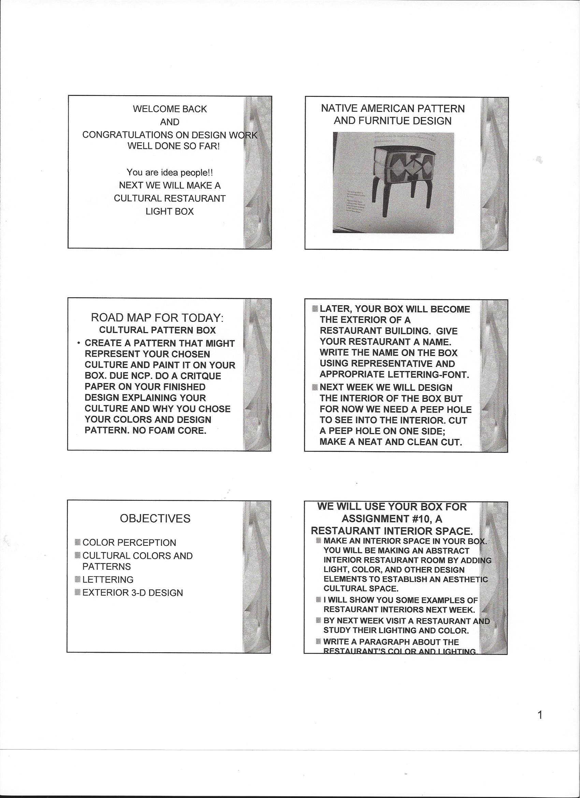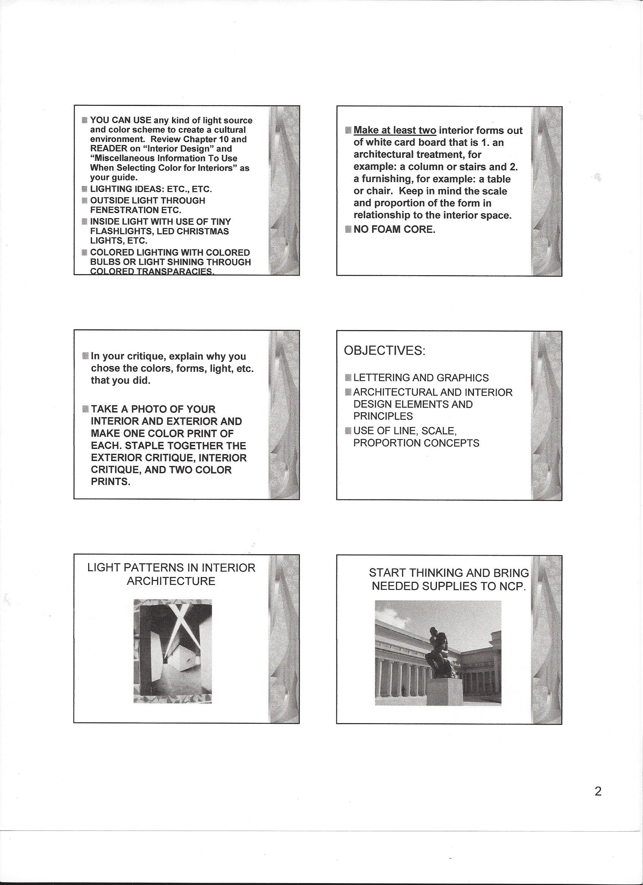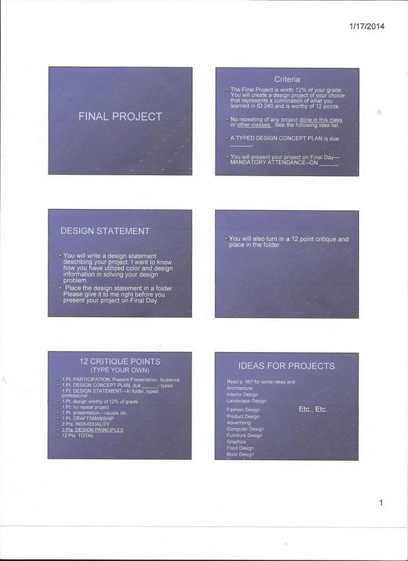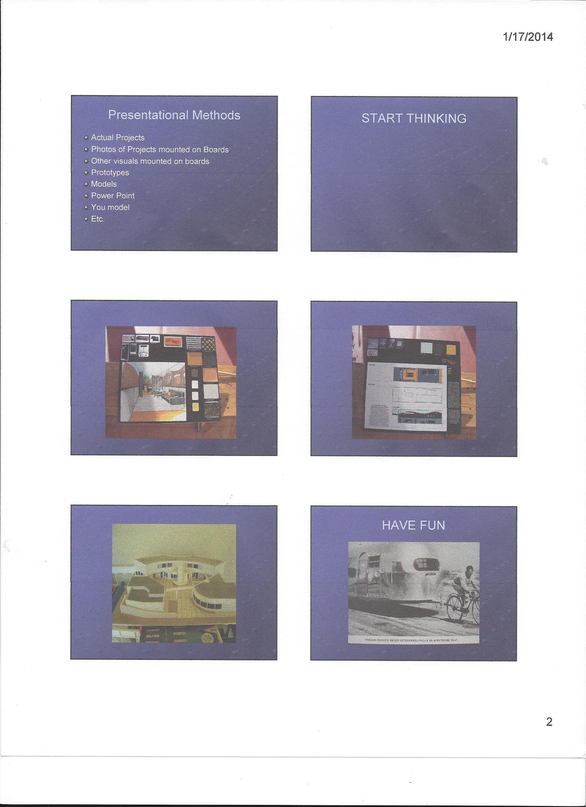

PAPER MOSAIC ASSIGNMENT

- WE WILL BE WORKING IN TEAMS OF 5. FORM YOUR TEAMS.
- LOOK AROUND BURK HALL AND SEE HOW THESE MOSAICS ARE DONE; CHIP BOARD THICKNESS; AND TECHNIQUE, I. E., RECYLED MAGAZINE PIECES GLUED TO BOARD.

- EACH TEAM WILL CHOOSE A COLORED PICTURE OF A PHOTO OR PAINTING TAKEN FROM THE FOLLOWING THEME OF PAINTINGS _________________________________________
- YOU CAN EARN EXTRA CREDIT IF YOU ATTEND ART GALLERIES TO GET IDEAS AND TURN IN A PARAGRAPH OF WHAT YOU SAW AND YOUR REACTION TO IT. ALWAYS SHOW YOUR STUDENT CARD FOR A LOWER FEE AND SEE IF YOU CAN BUY YOUR TICKET AHEAD OF VISIT FOR FEE REDUCTION. CHECK OUT MUNI PASS REDUCTIONS AND FRIDAY NIGHT EVENTS.

- TEAMS WILL COVER AN ENTIRE 4’X4’ SURFACE OF CHIP BOARD WITH THUMB SIZE, TORN MAGAZINE (RECYLE) PIECES GLUED ON WITH WHITE LIQUID GLUE (ELMERS). WHEN THE MOSAIC IS FINISHED THE MOSAIC WILL BE PAINTED (SEALED AND FINISHED) WITH WHITE GLUE THAT HAS BEEN THINNED SLIGHTLY WITH WATER. THE COLOR AND DESIGN OF YOUR MOSAIC SHOULD BE EXACTLY LIKE THE CHOSEN PICTURE.

- TEAMS: POOL MONEY FOR SUPPLIES AND EXCHANGE PHONE #S. BRING IN LIQUID GLUE, CHIP BOARD, AND MAGAZINES NEXT TIME. TEAMS CAN GO TO THE LIBRARY, ONLINE, ETC. AND CHOOSE A COLORED PHOTO OR PAINTING OF WHAT THEY WANT TO EMULATE AND BRING IT NEXT TIME.

DELEGATE:
- ONE MEMBER TO GET COLOR COPIES THAT WILL BE USED BY TEAM AND ONE LEFT IN AN ENVELOPE TAPED TO THE BACK OF THE 4X4 BOARD.
- TWO MEMBERS BRING IN BOARD AND WRITE NAME OF PAINTING OR PHOTO, ARTIST OR NAME, & TEAM MEMBER NAMES. CALL HOME DEPOT ETC. AND ASK IF THEY HAVE 4X4’ BOARDS BEFORE YOU GO AND MAKE SURE YOUR CAR IS BIG ENOUGH TO CARRY THE BOARD.
I CALLED HOME DEPOT IN MY AREA AND THEY HAD 4’X8’ CHIP BOARD, WHICH THEY WILL CUT TO 4’X4’ FOR $7.97 (DIVIDED BY 5 MEMBERS IS ABOUT $1.60 EACH).
- TWO MEMBERS TO BRING IN RECYCLED MAGAZINES TO TEAR INTO THUMB SIZE PIECES.
BY THE END OF THIS PERIOD, WRITE A LIST OF TEAM MEMBERS AND THEIR TASKS WITH THE NAME OF YOUR ARTIST AND PAINTING OR PHOTO IF YOU HAVE DECIDED UPON WHAT YOU’RE GOING TO COPY.

WRITE INDIVIDUAL CRITIQUES AND TURN IN ON DUE DAY ________ AT THE END OF THE PERIOD.

